**Conference Sandwiches Description:**

* We will be implementing a conference sandwiches website.
* We will have login and registration pages.
* When a user logs in to our website (with a username and password), he will search for a conference and place an order for a sandwich. The conference must be present-day or scheduled for a future date.
* The user may revisit the website to change his sandwich order (as long as the conference is not past).
* An admin will populate the scheduled conferences with their particular sandwich choices.
  + This entails that static sandwiches will be in place. No modifications.

**Implemented functions:**

**Login Functions:**  
Adding User Accounts - On the main log-in page a new person can click “New User” to create a new account.

User Login - Using a username and a password users can log in to the system. Admin users log into the admin portion of the site, others log into the user side of it.

Logout - By clicking the logout button, the user or admin can log out, and go back to the log in part of the site.

**Admin Functions:**

Add New Conference - Admins can add new conferences. Note, for the Conference Date section dates must be input in the format yyyy/mm/dd.

Delete Conferences - Admins can delete conferences. This also will delete the entries for what sandwiches that conference can have.

Edit Conferences Sandwich Selections - After clicking “Edit” next to a conference on the admin page, admins will go to a page where they can see what sandwiches are part of the conference, and can add/remove these sandwiches to/from the conference by clicking the respective add/remove buttons. The “Go Back” button on this page will return the user to the Conferences page for Admins

**User Functions:**

Search Conferences - Users can use a search field to search for conferences by conference name and/or by location. This search will return conferences that have the word looked for. (For example, for location, if you search for Dallas, it will return conferences for both “Dallas, TX” and “UT Dallas”)

Select a Conference and a Sandwich for the Conference - Users can select a conference under the users “Conference” tab, and then place orders on the following page for which sandwich they want. The “Go Back” button on this page will return the user to the Conferences page for Users.

View and Change Placed Orders - By clicking the Placed Orders tab, users can view the conferences they have orders for. Clicking the “View” button next to a conference allows the user to see their order for that conference. Once seeing these orders, clicking “Go Back” takes you back to the “Placed Orders” tab, clicking “Edit” next to one of the sandwiches will move take the user back to the sandwich selection phase so that they can change their order.

View Order History - Users can click on the “Order History” tab to view their order history.

**ER diagram:**

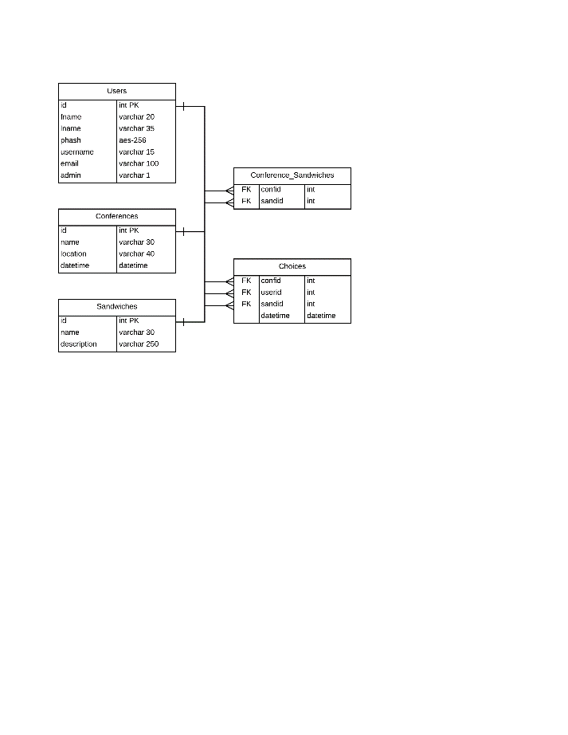

**CREATE TABLE statements for our schema (5 in total):**

|  |  |
| --- | --- |
| CREATE TABLE `users` (  `id` int(6) unsigned NOT NULL AUTO_INCREMENT,  `fname` varchar(20) DEFAULT NULL,  `lname` varchar(35) DEFAULT NULL,  `phash` aesFK-256 NOT NULL,  `username` varchar(15) DEFAULT NULL,  `email` varchar(100) DEFAULT NULL,  `admin` varchar(1) DEFAULT NULL,  PRIMARY KEY (`id`)  ) ENGINE=InnoDB AUTO_INCREMENT=13 DEFAULT CHARSET=utf8 | CREATE TABLE `conferences` (  `name` varchar(30) DEFAULT NULL,  `id` int(6) NOT NULL AUTO_INCREMENT,  `location` varchar(40) DEFAULT NULL,  `datetime` date DEFAULT NULL,  PRIMARY KEY (`id`)  ) ENGINE=InnoDB AUTO_INCREMENT=7 DEFAULT CHARSET=utf8 |
| CREATE TABLE `sandwiches` (  `name` varchar(30) DEFAULT NULL,  `description` varchar(1000) DEFAULT NULL,  `id` int(6) NOT NULL AUTO_INCREMENT,  PRIMARY KEY (`id`)  ) ENGINE=InnoDB AUTO_INCREMENT=7 DEFAULT CHARSET=utf8 | CREATE TABLE `conference_sandwiches` (  `confid` int(11) DEFAULT NULL,  `sandid` int(11) DEFAULT NULL,  KEY `confid` (`confid`),  KEY `sandid` (`sandid`),  CONSTRAINT `conference_sandwiches_ibfk_1` FOREIGN KEY (`confid`) REFERENCES `conferences` (`id`),  CONSTRAINT `conference_sandwiches_ibfk_2` FOREIGN KEY (`sandid`) REFERENCES `sandwiches` (`id`)  ) ENGINE=InnoDB DEFAULT CHARSET=utf8 |
| CREATE TABLE `choices` (  `datetime` date DEFAULT NULL,  `confid` int(6) DEFAULT NULL,  `userid` int(6) unsigned DEFAULT NULL,  `sandid` int(6) DEFAULT NULL,  KEY `confid` (`confid`),  KEY `userid` (`userid`),  KEY `sandid` (`sandid`),  CONSTRAINT `choices_ibfk_1` FOREIGN KEY (`confid`) REFERENCES `conferences` (`id`) ON DELETE CASCADE,  CONSTRAINT `choices_ibfk_2` FOREIGN KEY (`userid`) REFERENCES `users` (`id`) ON DELETE CASCADE,  CONSTRAINT `choices_ibfk_3` FOREIGN KEY (`sandid`) REFERENCES `sandwiches` (`id`) ON DELETE CASCADE  ) ENGINE=InnoDB DEFAULT CHARSET=utf8 |  |

**Screenshots of main functionalities, below:**

**Login Screenshots**

Login Page:

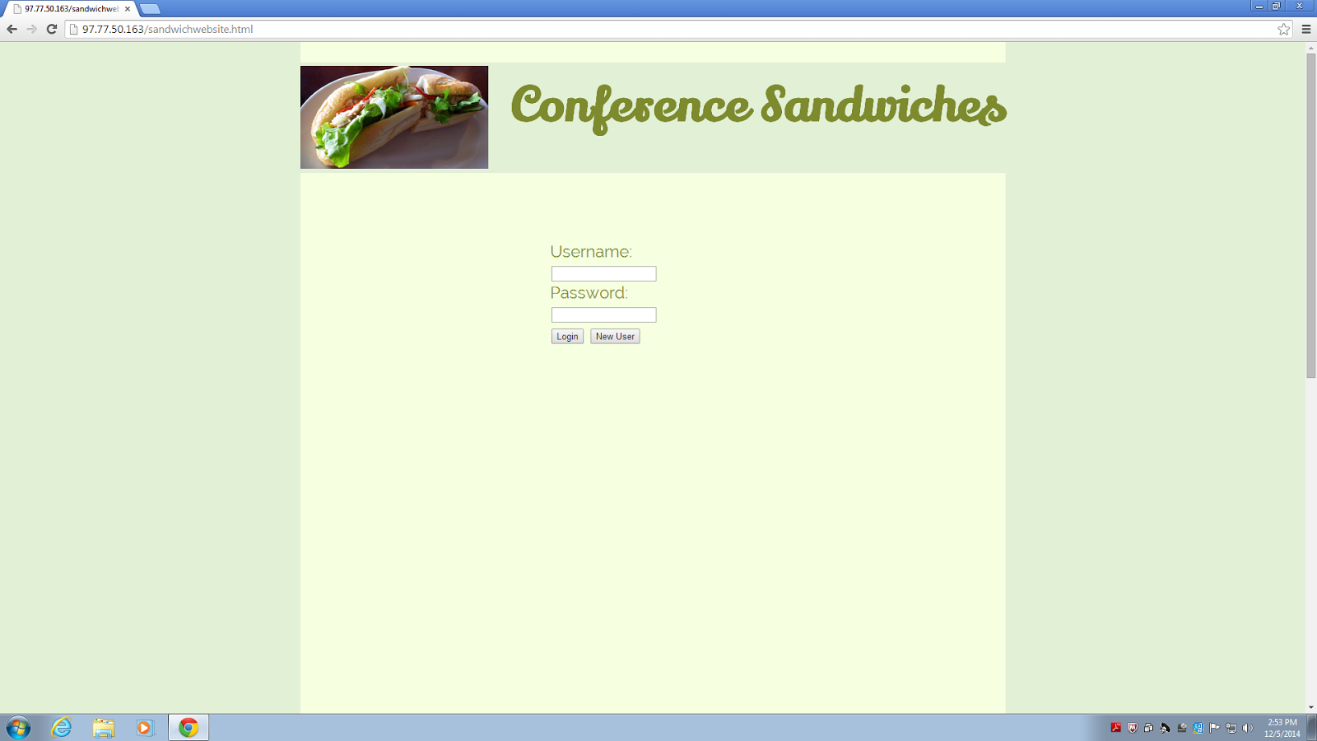

**New User Page:**

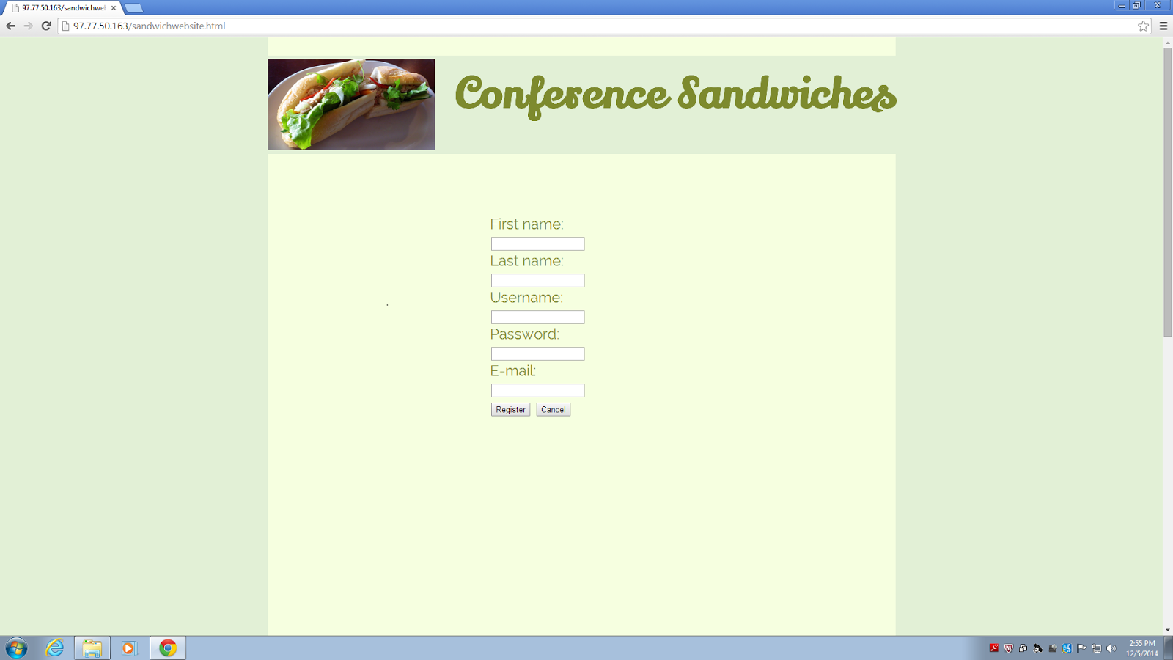

Some Messages that can occur while making new users:

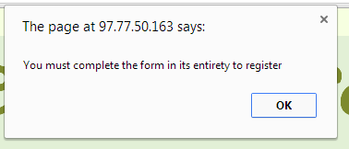

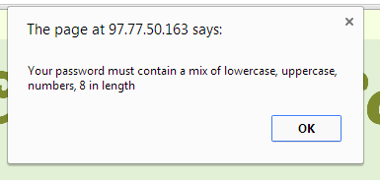

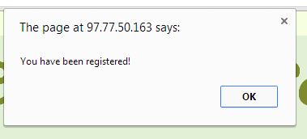

**Admin Screenshots:**

Admin Page:

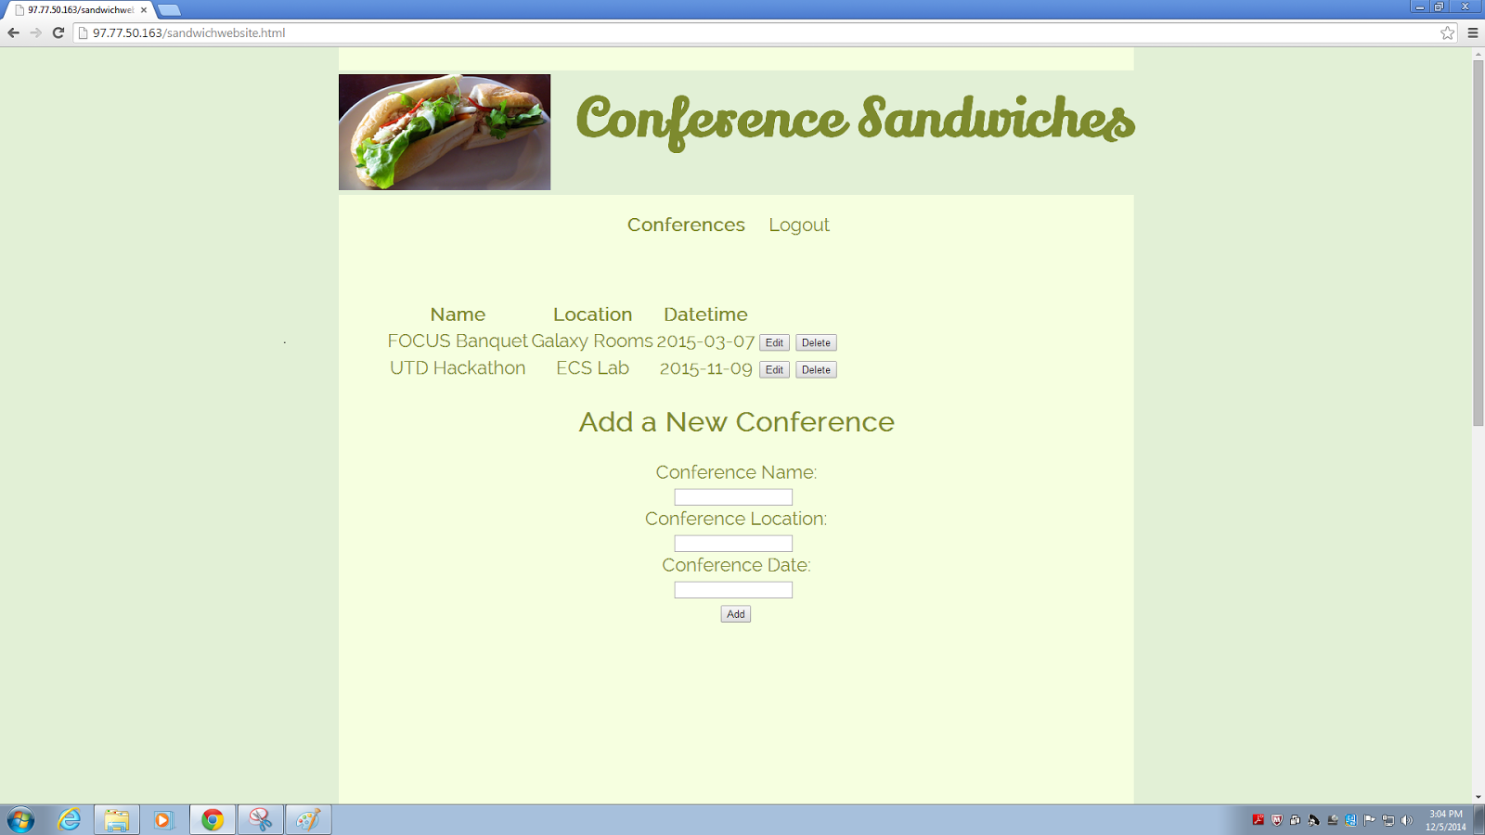

Page to add or remove sandwiches from the conference:

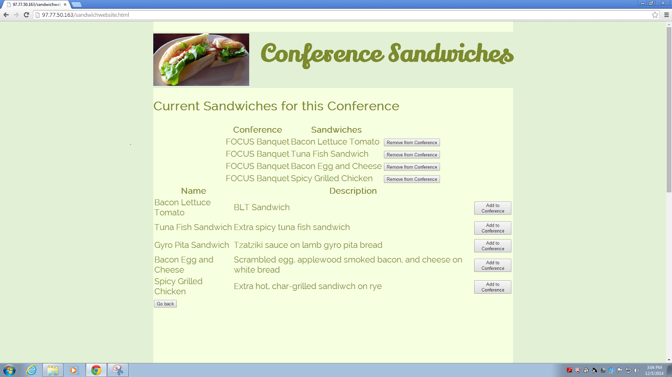

**User Screenshots:**

User Conference Page:

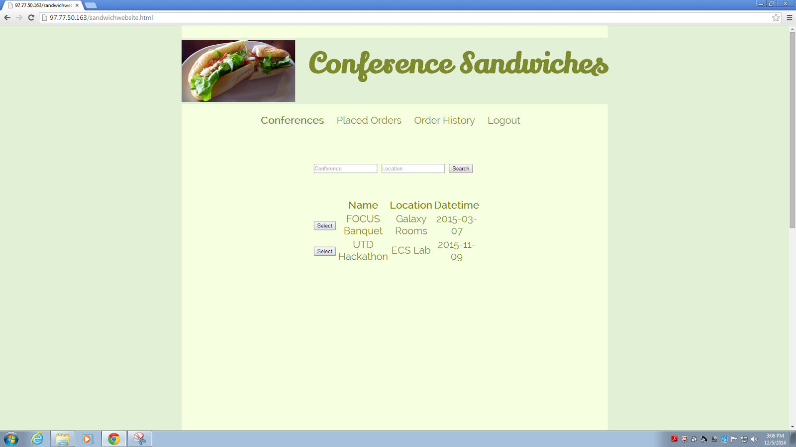

Conference Search Result:

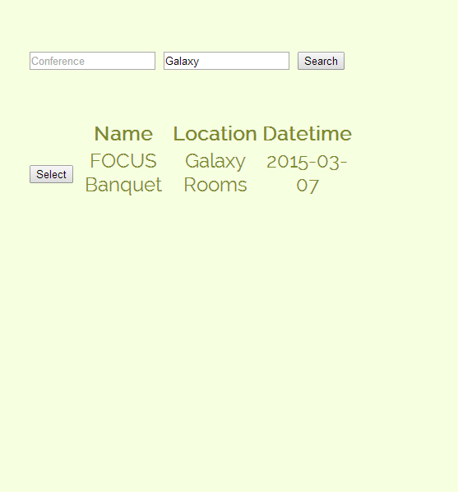

Page After Selecting a Conference:

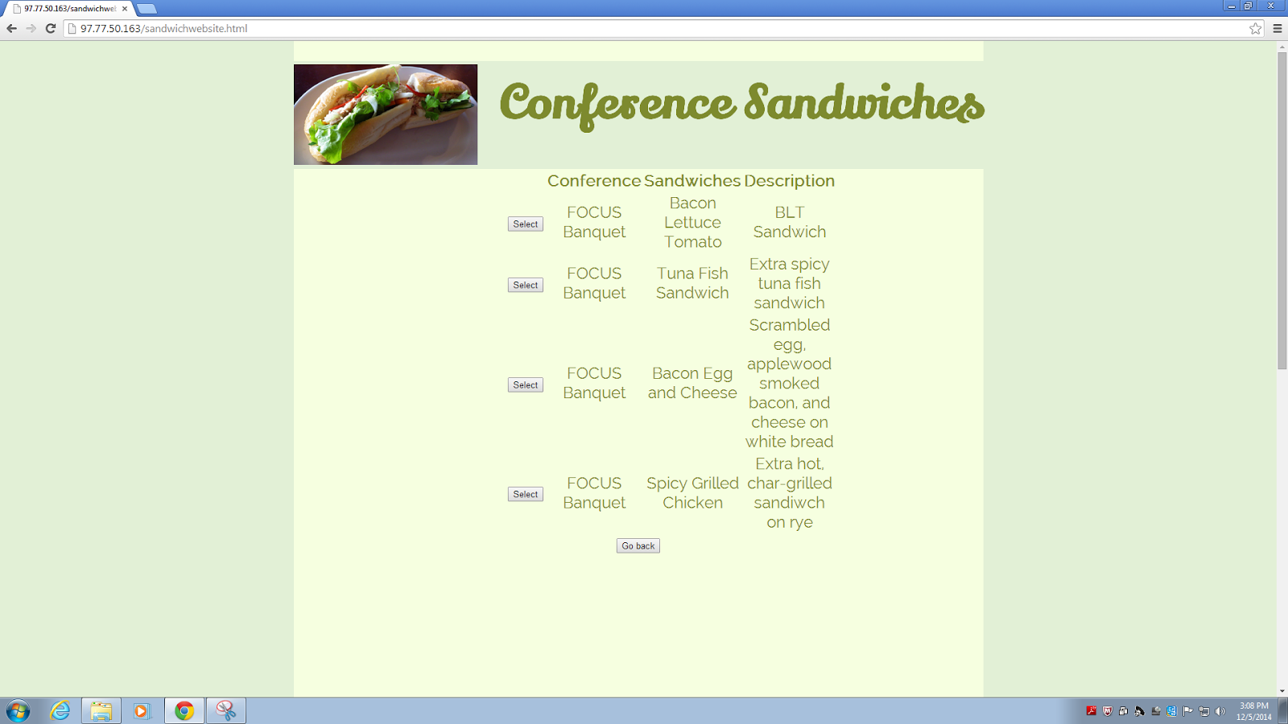

Dialogues After Selecting a Sandwich or cancelling:

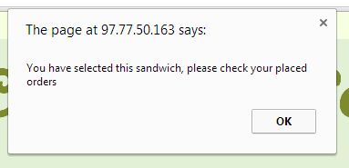

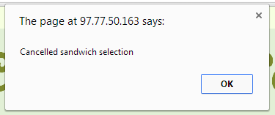

The Place Order Page:

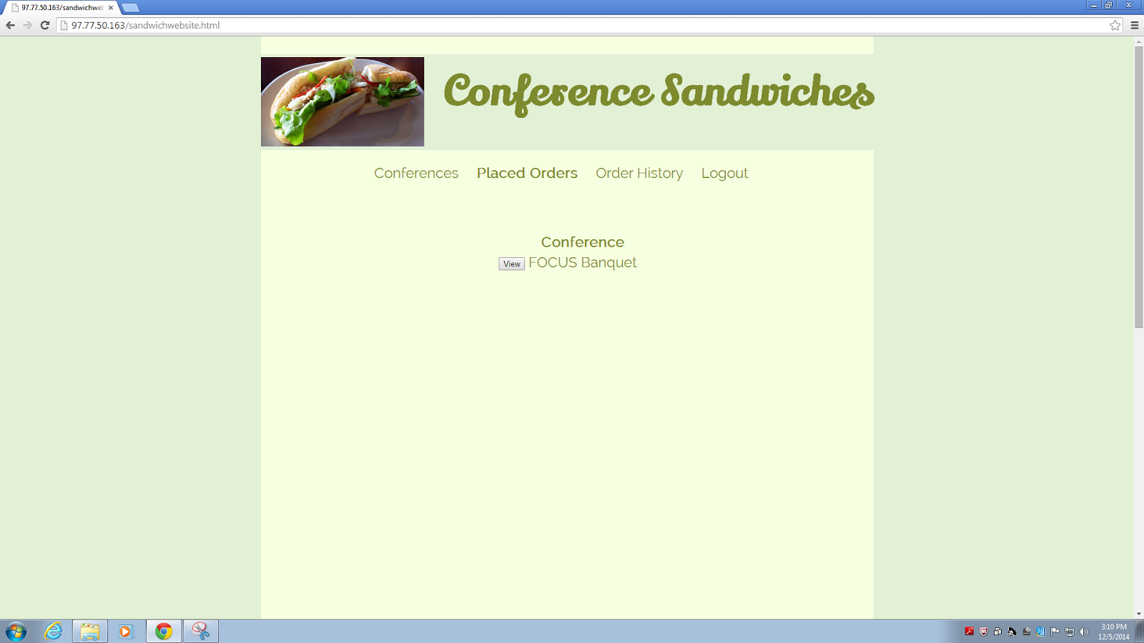

After Clicking to View Placed Orders for a Specific Conference:

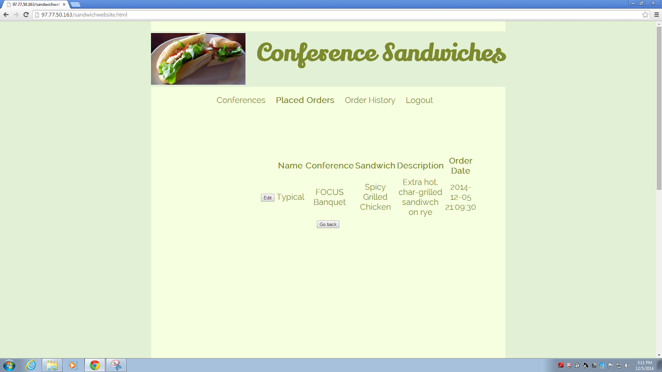

Clicking Edit Results in a page like the earlier screenshot for “Page After Selecting a Conference:”, except for the respective conference.

Order History Page:

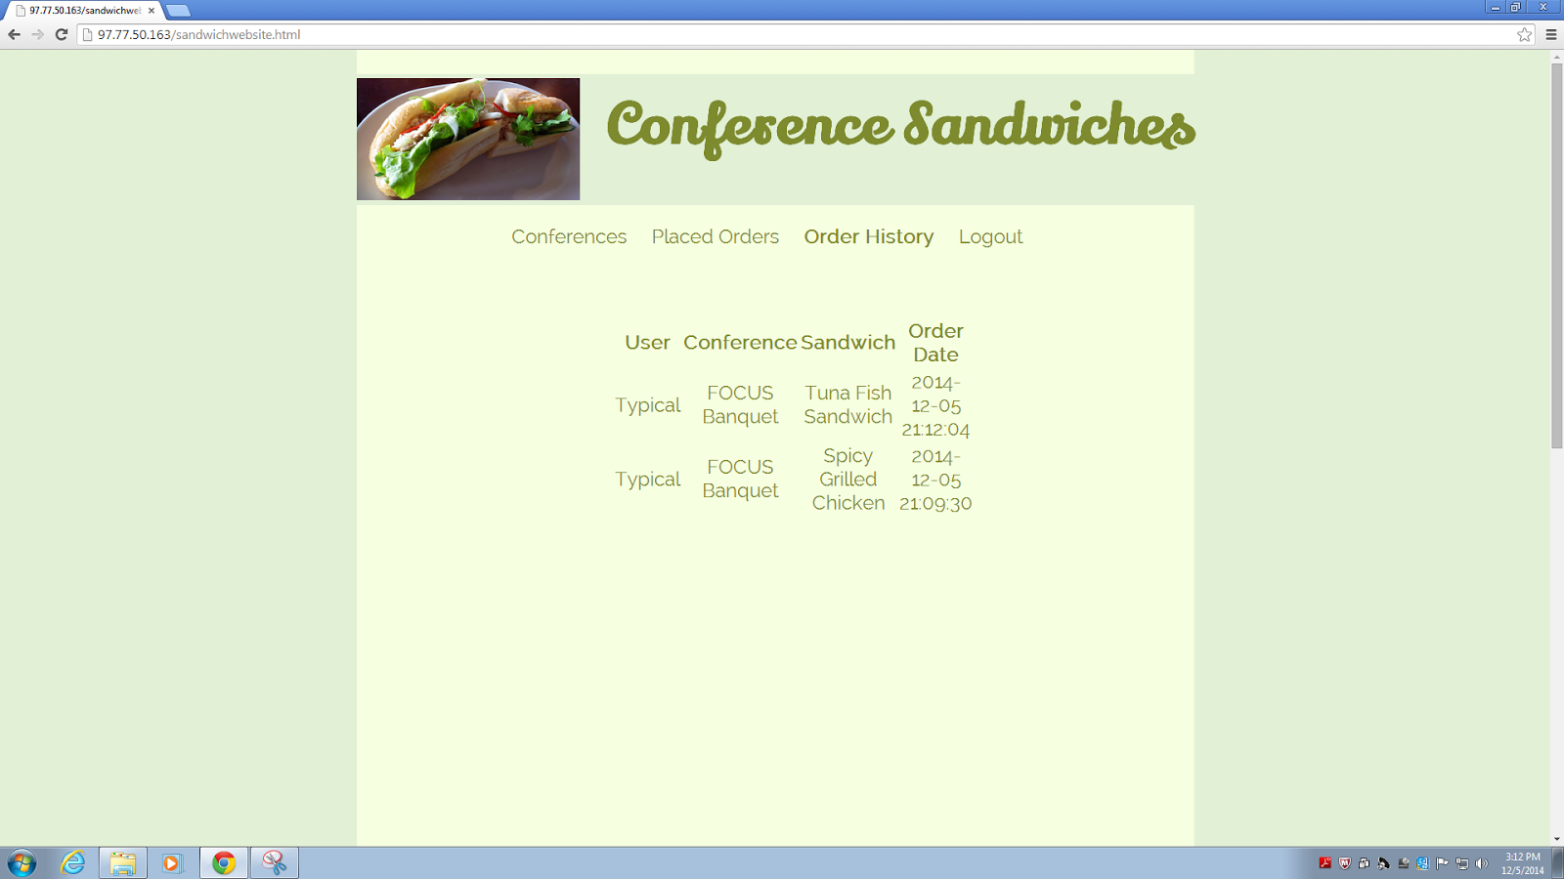

Logout, will obviously take us back to the user login page.

All source code is zipped together in our folder: Team 4 – Mohrman Sanders – Project.zip